- Create a new GitHub repository named 'my-movie-ratings' and push a local Jupyter notebook file (movie_ratings.ipynb) to it using git commands (init, add, commit, remote add, push).

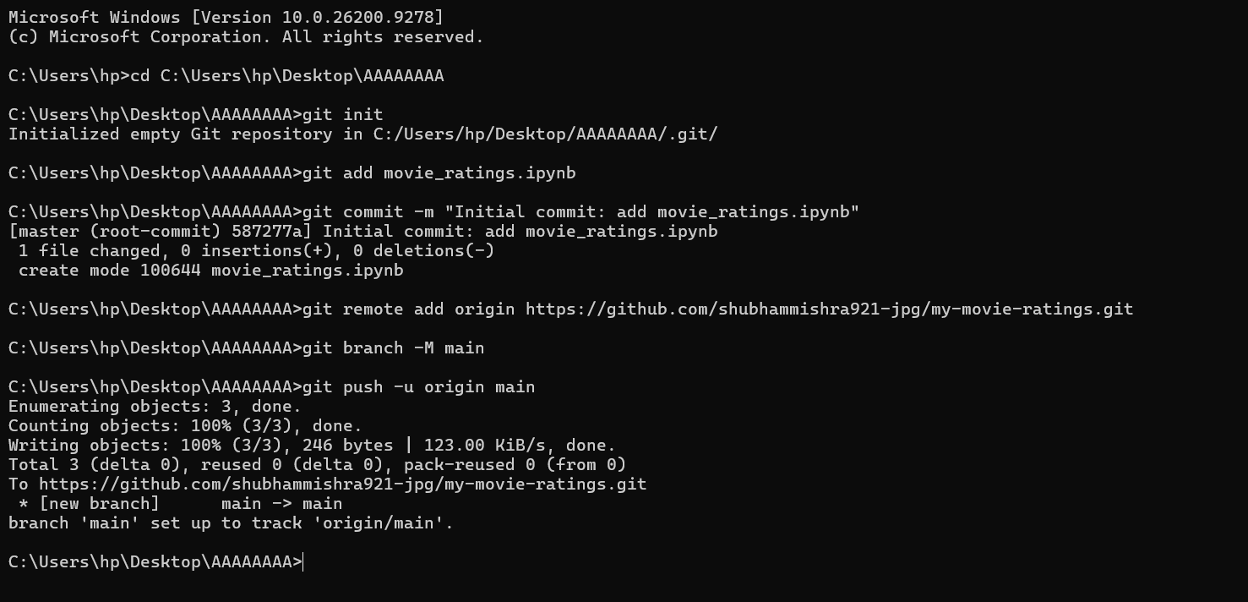

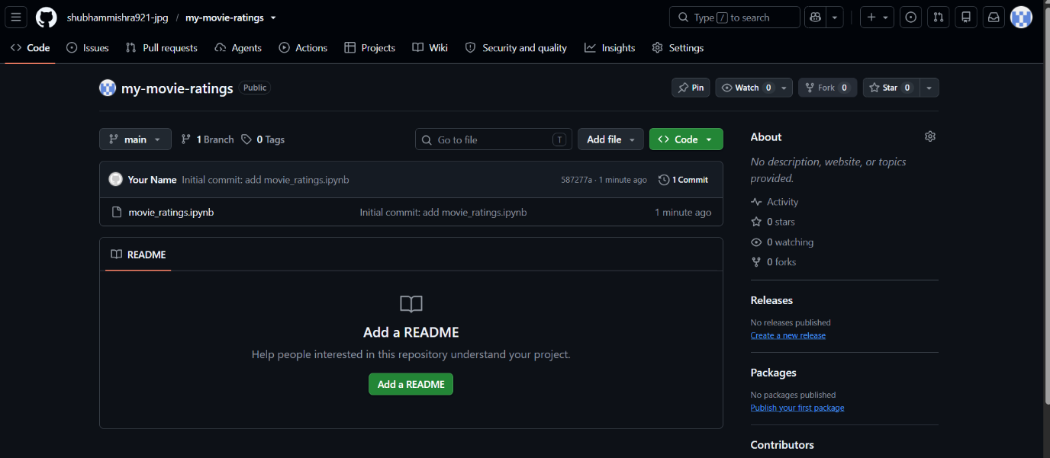

- Add a large sample CSV file (over 100MB, e.g., fake Spotify playlist data) to your repo using Git LFS instead of regular git, and explain in a README.md why raw data files should not be uploaded directly to GitHub repos.Use 'git lfs track' and mention privacy, storage, and bandwidth issues in your explanation.

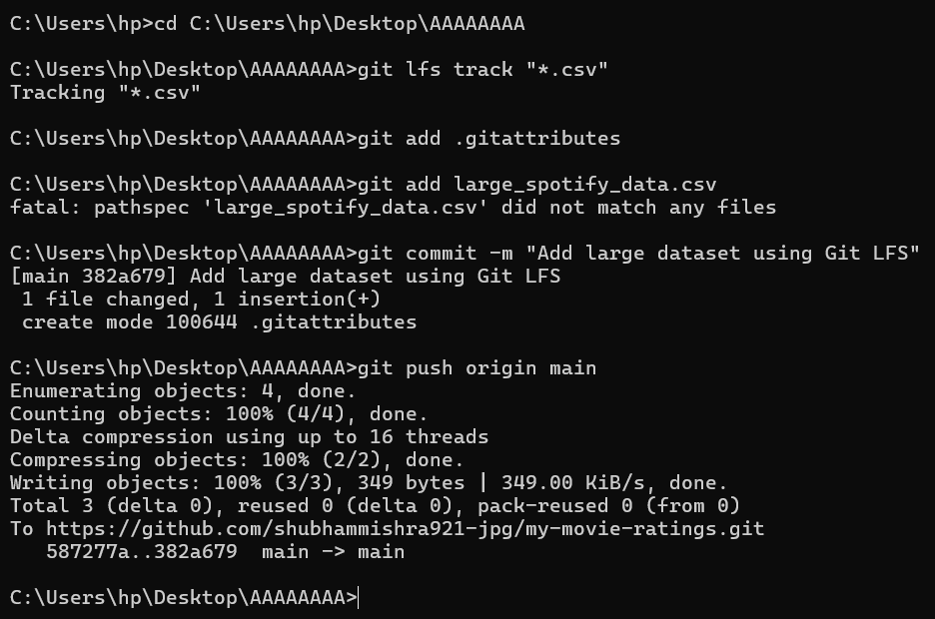

- Install nbdime and use it to show the difference between two versions of a Jupyter notebook (e.g., before and after adding a new plot about IPL player runs). Paste the nbdime diff output (screenshot or text) in your repo's README.

Step 1: Install nbdime using Python
Run this command to make sure it installs correctly:
Bash
python -m pip install nbdime

Step 2: Enable Git Integration using Python
Instead of the shortcut command, run the configuration command through Python:
Bash
python -m nbdime config-git --enable
(Verify step: You should see a success message indicating that Git configuration has been updated for nbdime).

Step 3: Run the diff command
Now you can view the changes in your notebook by running:
Bash
git diff movie_ratings.ipynb
Once you see the diff output, copy a snippet of it, add it to your README.md file under a new section, and push it:
Bash
git add README.md
git commit -m "Add nbdime diff output to README"
git push origin main

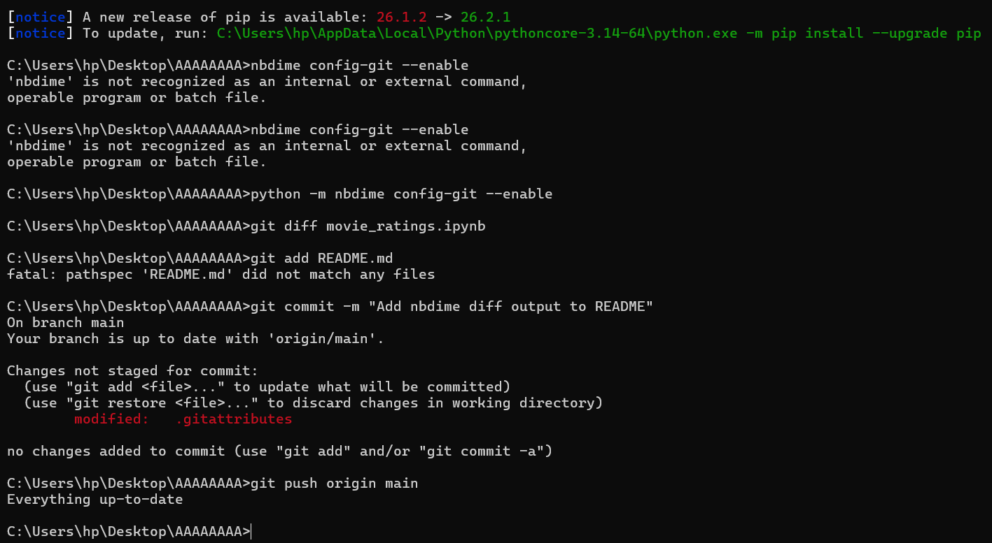

- Showcase your data science work by adding to your GitHub repo: a Jupyter notebook (analysis.ipynb), a processed dataset (processed_data.csv), a plot image (plot.png), and a Python script (helper_functions.py). Do not include raw or unprocessed data files.

git add analysis.ipynb processed_data.csv plot.png helper_functions.py
git commit -m "Add data science portfolio files"
git push origin main

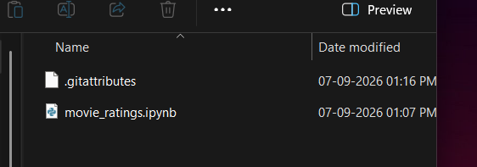

5. Build a simple GitHub Pages portfolio site from your repo, add at least two project cards (e.g., 'Instagram Follower Analysis', 'Zomato Restaurant Ratings'), and link your resume as a downloadable PDF.
